THE BAGHPAT CO-OPERATIVE SUGAR MILLS LTD.

BAGHPAT - 250609 (U.p.)

Email: bptsugar@gmail.com

Website: www.upsugarfed.org

COMPETATIVE e-Bidding

FOR

A.M.C. Computer Networking & Supply of Networking's hardware for the Season 2023-24.

E-Bid REFERENCE : BCSM/MP/TENDER/2023-24/1381

LAST DATE AND TIME FOR : 15.09.2023 – AT 06.00 P.M.

SUBMISSION OF E-Bids

DATE AND TIME OF OPENING : 16.09.2023 – AT 11.15 A.M.

OF ON LINE TECHNICAL e-Bids

PLACE OF OPENING OF e-Bids : THE BAGHPAT CO-OPERATIVE SUGAR MILLS LTD., BAGHPAT 250609 (U.P.)

ADDRESS FOR COMMUNICATION : General Manager

THE BAGHPAT CO-OPERATIVE SUGAR MILLS LTD., BAGHPAT 250609 (U.P.)

E-Bid EMD : Rs. 2000/-

This Document Contains -- 27 Pages

It will be the responsibility of the e-Bidders to check U.P. Government e-Procurement website http://etender.up.nic.in for any amendment through corrigendum in the e-tender document. In case of any amendment, e-Bidders will have to incorporate the amendments in their e-Bids accordingly.

e-tender Document Processing /Cost : Rs 590.00 With GST

INDEX

1 | e- Tender Notice | 03-05
2 | Invitation of e-Bids | 06-08
3 | Section I- Instruction to Bidders | 09-17
 | (A) The e-Bid Document | 09-10
 | (B) Preparation of e-Bids | 10-15
 | (C) e-Bid Opening and Evaluation of e-Bid | 16-18
 | (D) Award of Contract | 18
4 | Section II- Conditions of Contract | 19-20
5 | Section III- Technical e-Bid | 21
 | III (A) e Bid form | 22
 | III (B) Schedule of Requirements/ Tender Quantity | 23
 | III (C) General Information & Capability Statement | 24
6 | Section IV- Financial e-Bid | 25
 | IV(A) e- Bid Form | 26
 | IV (B) Price Schedule/BOQ | 27
7 | CHECK LIST | 28

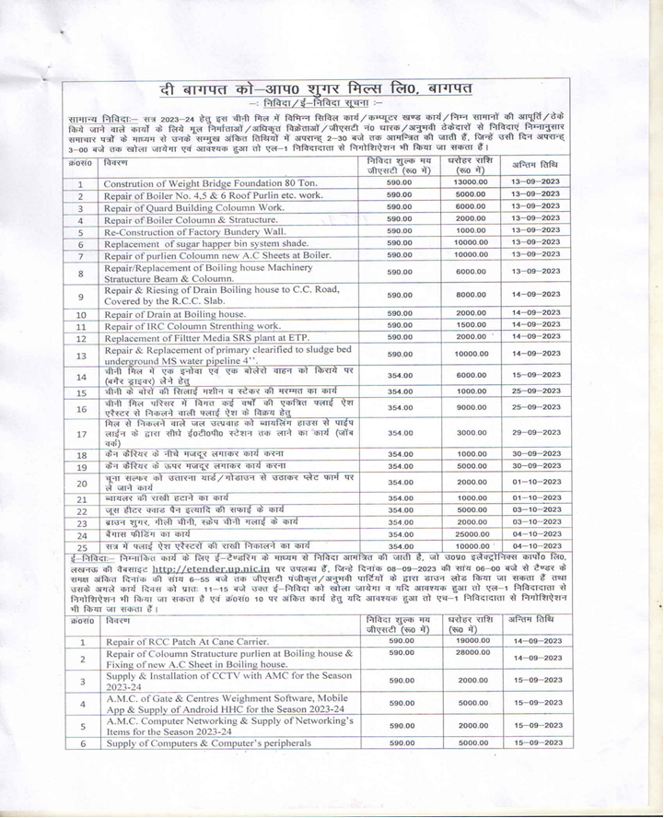

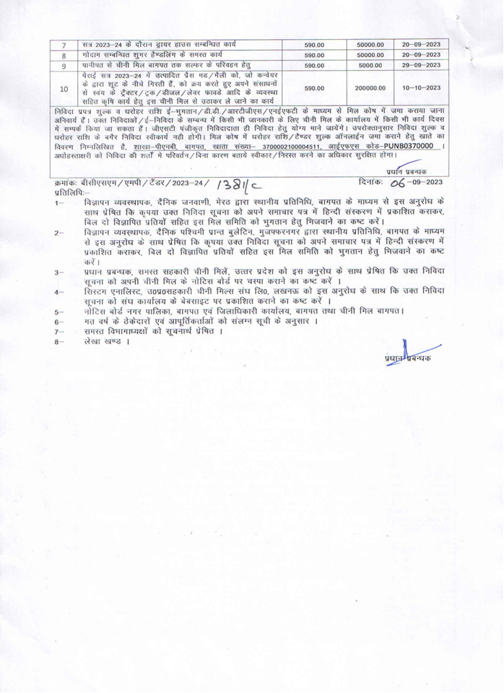

INVITATION FOR e-Bids

Online e-Bids are invited for A.M.C. Computer Networking & Supply of Networking's hardware for the Season 2023-24.within UP and outside state from bonafide Suppliers.

Bidders are advised to study the Tender Document carefully. Submission of E-Bid against this Tender shall be deemed to have been done after careful study and examination of the procedures, terms and cond itions of the Tender Document with full understanding of its implications.

The e-Bid prepared in accordance with the procedures enumerated in ITB Clause 15 of Section-I should be submitted through e-Procurement website http://eTender.up.nic.in.

(a) | Date of publication of e-Tender notice & availability of Tender Document | Tender Notice has been published over e-Procurement website http://etender.up.nic.in and Federation’s website www.upsugarfed.org  and Tender Document will be available from  08.09.2023at 06:00 PM e-Procurement web site http://eTender.up.nic.in and Federation’s website www.upsugarfed.org
(b) | Availability of Tender document on website | 08.09.2023at 06:00 PM at e-Procurement web site http://etender.up.nic.in and Federation’s website www.upsugarfed.org
(c) | Clarification start date & time | 08.09.2023at 06:00 PM
(d) | Clarification end date & time | 15.09.2023 upto 06:00 PM
(e) | E-Bid submission start date & time (Submission of e-Tender fee, EMD and other supporting documents in PDF/XLS format) | 08.09.2023at 06:00 PM
(f) | E-Bid submission end date & Time | 15.09.2023 upto 06:00 PM
(g) | Online technical e-Bid opening date & time | 16.09.2023from 11:15 AM
(h) | Online financial e-Bid opening date & time (Only of technically qualified bidders) | 16.09.2023from 11.30 AM
(i) | Venue of opening of technical & financial e-Bids | THE BAGHPAT CO-OPERATIVE SUGAR MILLS LTD.  BAGHPAT - 250609 (U.P.).
(j) | Contact officer | Name: C.C.O.  Mobile: 07880888924  Email: bptsugar@gmail.com
(k) | Cost of e-Bid document | Rs 590.00 With GST (Rupees Five Hundred Ninty Only) (Non-refundable)
(l) | E-Bid Earnest Money | Rs 2000.00 (Rupees FiveThousand).

The Tender document is available at e-Procurement website http://eTender.up.nic.in or Federation’s website www.upsugarfed.org from 08.09.2023at 06:00 PM. interested bidders may view, download the e-Bid document, seek clarification and submit their e-Bid online up to the date and time mentioned in the table below:

The bidders need to submit the proof/cost of e-Bid document/processing as stated in the above table in Cash in the office or through Demand Draft/RTGS in favor of Kisan Sahakari Chini Mills Ltd, BAGHPAT - 250609 (U.p.) (herein after referred as MILL payable at BAGHPAT - 250609 (U.p.). The scanned copy of the Cash Deposit Receipt or Demand Draft/RTGS must be enclosed along with the E-Bids but the original Demand Draft/RTGS should reach the office of MILL payable at BAGHPAT - 250609 (U.p.) before opening of technical E-Bid.

All E-Bid must be accompanied by e-Bid Earnest Money Deposit (EMD) in the form of Demand Draft/RTGS, drawn in favour of THE BAGHPAT CO-OPERATIVE SUGAR MILLS LTD., BAGHPAT - 250609 (U.P.). The scanned copy of the E-Bid EMD must be submitted along with the e-Bid and the original should reach the MILL’s office at BAGHPAT - 250609 (U.P.).before opening of technical e-Bids. No Interest would be payable on e-Bid (Earnest Money) deposited with the Federation.

The e-Bids will be electronically opened in the presence of bidder’s representatives, who choose to attend at the venue, date and time mentioned in the above table. An authority letter of bidders’ representative will be required to be produced.

The MILL reserves the right to cancel any or all the e-Bids/annul the e-Bid process without assigning any reason thereof. The decision of GENERAL MANAGER will be final and binding.

In the event of date specified for E-Bids opening being declared a holiday for in mills then the due date for opening of E-Bids shall be the next working day at the appointed time and place.

All the required documents including Price Schedule/BOQ should be uploaded by the E-Bidder electronically in the PDF/XLS format. The required electronic documents for each document label of Technical (Fee details, Qualification details, E-Bid Form) schedules/packets can be clubbed together to make single different files for each label.

The companies/firms who are registered at E-Procurement portal for E-Tendering with UP Electronics Corporation Ltd, 10 Ashok Marg, Lucknow-226001, would only be eligible for participating in this E-Tender as well as in E-Tendering system of U.P. Govt. departments. All companies/firms who have not registered themselves with UP Electronics Corporation Ltd for E-Tendering till date can get their registration done by depositing a filled in form issued by UP Electronics Corporation Ltd along with registration fee of 6000.00 (Rupees Six thousand only) for participating in this e-Tender and other e-Tenders of U.P. Govt. Department. The companies/firms, who are not having digital signature, can also get their digital signature on deposit of processing fees of 1500.00 (Rupees One thousand five hundred only). The companies/firms may contact the officials on phone numbers (0522) 4130303 (Extn: 305/307) or (M: 09721451211), for their Registration/Digital Signature Certificate related queries.

For E-Tendering Enquiry Please Contact Following Persons

- Sr. Dy. Manager(E.D.P.) - +91-6389025019

SECTION I : INSTRUCTIONS TO BIDDERS (ITB)

(A) THE BID DOCUMENT

1-Cost of e-Bid

a) The bidder shall bear all costs associated with the preparation and submission of its e-Bid and THE BAGHPAT CO-OPERATIVE SUGAR MILLS LTD., Baghpat - 250609 (U.P.), hereinafter referred to as “the Mill”, will in no case be responsible or liable for these costs, regardless of the conduct or outcome of the e-Bid process.

b) This Tender document is available on the web site http://eTender.up.nic.in and www.upsugarfed.org to enable the bidders to view, download the e-Bid document and submit e-Bids online up to the last date and time mentioned in e-Tender notice/e-Tender document against this e-Tender. The bidders shall have to pay e-Tender document fee of Rs 590.00 With GST (Rupees Five Hundred Ninty Only) in cash or through Demand Draft/RTGS payable in favour of THE BAGHPAT CO-OPERATIVE SUGAR MILLS LTD., BAGHPAT - 250609 (U.P.). The scanned copy of the Cash Deposit Receipt or Demand Draft/RTGS must be enclosed along with the e-Bid but the original Demand Draft/RTGS should reach the Mill’s office before opening of the technical E-Bid. This E-Tender document fee of Rs. 590.00 With GST will be non-refundable.

2-Contents of e-Bid Document

2.1 The A.M.C. of Gate & Centres Weighment Software, Mobile App & Supply of Android HHC for the SEASON 2023-24 required to be supplied, e-Bid procedure and contract terms and conditions are prescribed in the e-Bid document. The e-Bid document includes:

Invitation for e-Bid

Section I : Instruction to bidders (ITB);

Section II : Conditions of Contract (CC);

Section III : Technical e-Bid;

Section IV : Financial e-Bid;

2.2- The bidder is expected to examine all instructions, forms, terms and specifications in the e-Bid document. Failure to furnish all information required as per the e-Bid document or submission of e-Bid not responsive to the e-Bid document in every respect will be at the bidder’s risk and may result in rejection of the said e-Bid.

3-Clarification of e-Bid Document

A prospective bidder requiring any clarification of the e-Bid document may raise his/her point of clarification through Bid Management Window after successfully login to the e-Procurement website http://eTender.up.nic.in. The bidder may seek clarification by posting query in the relevant window after clicking "Seek Clarification" option in the view e-Tender details window for e-Tender which can be selected through my Tender option of e-Bid submission menu. The clarification will be replied back by the Mill through the e-Procurement website which can be read by the bidder through the "Clarification" option under Bid Submission menu. The Mill may also respond to clarifications raised by the prospective bidders on Mill's e-mail address : bptsugar@gmail.com.

4. Amendment of e-Bid Document

4.1 At any time prior to the deadline for submission of e-Bid, the Mill may, for any reason, whether at its own initiative or in response to a clarification requested by a prospective bidder, modify the e-Bid document by amendments. Such amendments shall be uploaded on the e-Procurement website http://etender.up.nic.in and Mill’s web site www.upsugarfed.org through corrigendum and shall form an integral part of e-Bid document. The relevant clauses of the e-Bid document shall be treated as amended accordingly.

4.2 It shall be the sole responsibility of the prospective bidders to check the web site http://etender.up.nic.in and www.upsugarfed.org from time to time for any amendment in the e-Tender document. In case of failure to get the amendments, if any, the Mill shall not be responsible for it.

4.3 In order to allow prospective e-Bidders a reasonable time to take the amendment into account in preparing their e-Bids, the Mill, at his discretion, may extend the deadline for the submission of e-Bids. Such extensions shall be uploaded on the e-Procurement website http://etender.up.nic.in and Mill’s web site www.upsugarfed.org.

(B) PREPARATION OF e-Bid

5 Language of e-Bid

5.1 The e-Bid prepared by the bidder, as well as all correspondence and documents relating to the e-Bid exchanged by the bidder and the Mill shall be written either in English or Hindi language. The correspondence and documents in Hindi must be accompanied by embedded/separate Hindi font files. Only English numerals shall be used in the e-Bid.

6 Documents Constituting the e-Bid

6.1 The e-Bid prepared by the bidder shall comprise the following components:

(a) Technical e-Bid - Technical e-Bid will comprise of :

(i) Fee Details – includes copies of e-Tender document processing/Cost and e-Bid Earnest Money Deposit (EMD) furnished in accordance with ITB Clause 12 in PDF format.

(ii) Qualification Details – includes copies of required documents as per ITB Clauses 10 and 11 in PDF format justifying that the bidder is qualified to perform the contract if his/her bid is accepted and that the bidder has financial, technical and Consumption capability necessary to perform the contract and meets the criteria outlined in the Qualification Requirement and Technical Specification and fulfill all the conditions of the Contract.

(iii) e-Bid Form – includes copy of filled in e-Bid Form as per Section-III(A) of e-Tender document in PDF format justifying that the bidder is complying with all the conditions of the Contract and Technical Specifications of the e-Bid Document as no deviation will be acceptable to the Mill.

(iv) Technical Specification Details – includes copy of filled in Technical Specifications as per Section-III(C) of e-Tender document in PDF format.

(b) Financial e-Bid – Financial e-Bid will comprise of:

(i) e-Bid Form – includes copy of filled in e-Bid Form as per Section-IV (A) of e-Tender document in PDF format.

(ii) Price Schedule/BOQ – includes Price Schedule/BOQ in XLS format to be filled in after downloading from the e-Procurement website for this e-Tender.

7-e-Bid Form

7.1 The bidder shall complete the e-Bid Form and the appropriate Price Schedule/BOQ furnished in the e-Bid document, including the goods to be purchased, their quantities and prices in the format given in the e-Bid document.

8 e-Bid Price

8.1 The bidder shall quote separately in the downloaded spread sheet file for the Price of A.M.C. Computer Networking & Supply of Networking's hardware for the Season 2023-24.to be supplied to Mill.

8.2- The price of A.M.C. Computer Networking & Supply of Networking's hardware for the Season 2023-24.exclusive of All Taxes.

8.3- Prices quoted by the bidder shall be fixed during the validity period of the Contract and not subject to variation on any account subject to ITB Clause 25.1.

A- E-Bid submitted with an adjustable price quotation unless asked for shall be treated as non-responsive and rejected.

9 e-Bid Currencies

Prices shall be quoted in Indian Rupees only.

10 Documents Establishing bidder’s Qualification

10.1 Pursuant to ITB Clause 6, the bidder shall furnish, as part of its Technical e-Bid, documents establishing the bidder’s qualification to perform the Contract if its e-Bid is accepted. The documentary evidence should be submitted by the bidder electronically in the PDF format.

The documentary evidence of bidder’s qualification to perform the Contract if its e-Bid is accepted shall be as per Qualification Requirements specified in e-Tender document.

11 Documents Establishing A.M.C. Computer Networking & Supply of Networking's hardware for the Season 2023-24.Conformity to e-Bid Documents

11.1 Pursuant to ITB Clause 6, the bidder shall furnish, as part of its e-Bid, documents establishing the conformity to the e-Bid documents of all goods and services which the bidder proposes to Lifting under the contract. The documentary evidence should be in the PDF file format.

12 e-Bid Earnest Money Deposit (EMD)

12.1 Pursuant to ITB Clause 6, the bidder shall furnish, as part of its e-Bid, an e-Bid EMD of Rs 2000.00 (Rs. Two Thousand Only) in the form of Demand Draft/RTGS, in favour of THE BAGHPAT CO-OPERATIVE SUGAR MILLS LTD., BAGHPAT - 250609 (U.p.). The scanned copy of the e-Bid EMD must be submitted along with the e-Bid and the original should reach the Mill’s office at Chini Mill Baghpatbefore opening of technical e-Bid.

NEFT/RTGS DETAIL

Name of Bank & Branch :: PUNJAB NATIONAL BANK, BAGHPAT
IFSC Code No. :: PUNB0370000
Bank A/C No. :: 3700002100004511
Name of beneficiary :: THE BAGHPAT CO-OPERATIVE SUGAR MILLS LTD.,

12.2 The e-Bid EMD is required to protect the Mill against the risk of bidder’s conduct which would warrant the Earnest’s forfeiture, pursuant to ITB Clause 12.7.

12.3 The e-Bid EMD shall be in Indian Rupees and shall be in the following forms only:

A Demand Draft/RTGS payable in favour of The Baghpat Co-operative Sugar Mills Ltd., Baghpat

12.4 Any e-Bid not secured in accordance with ITB Clauses 12.1 and 12.3 above shall be treated as non-responsive and rejected by the Mill.

12.5 Unsuccessful bidder’s e-Bid EMD will be returned upon the written request through cheque as promptly as possible.

12.6 The e-Bid EMD may be forfeited:

(a) if a bidder (i) withdraws its e-Bid during the period of e-Bid validity specified by the Mill on the e-Bid Form; or (ii) does not accept the correction of errors pursuant to ITB Clause 22.2; or (iii) modifies its e-Bid price during the period of e-Bid validity specified by the Mill on the e-Bid form or

(b) In case of a successful bidder, if the bidder fails:

(i) To sign the Contract with the Mill in accordance with ITB Clause 28; or

(ii) To furnish performance security in accordance with ITB Clause 29.

13 Period of Validity of e-Bid

13.1 E-Bid shall remain valid upto 45 days and the Rate contract for the period up to end of the crushing season 2022-23.

13.2 In exceptional circumstances, the Mill may solicit the bidder’s consent to an extension of the period of e-Bid validity. The request and the response thereto shall be made in writing. A bidder may refuse the request without forfeiting its e-Bid security. A bidder granting the request will not be required nor permitted to modify its e-Bid.

14 Format and Signing of e-Bid

14.1- The bidder shall prepare one electronic copy each of the Technical e-Bid and Financial e-Bid separately.

14.2- The E-Bid document shall be digitally signed, at the time of uploading, by the bidder or a person or persons duly authorized to bind the bidder to the Contract. The later authorization shall be indicated by a scanned copy of written power-of-attorney accompanying the e-Bid. All the pages/ documents of the e-Bid that are to be uploaded shall be digitally signed by the person authorized to sign the e-Bid.

15. Submission of e-Bid

The Bid Submission module of e-Procurement website http://eTender.up.nic.in enables the bidders to submit the e-Bid online in response to this e-Tender published by the Mill. Bid Submission can be done only from the Bid Submission start date and time till the Bid Submission end date and time given in the e-Tender. Bidders should start the Bid Submission process well in advance so that they can submit their e-Bid in time. The bidders should submit their e-Bid considering the server time displayed in the e-Procurement website. This server time is the time by which the e-Bid submission activity will be allowed till the permissible time on the last/end date of submission indicated in the e-Tender schedule. Once the e-Bid submission date and time is over, the bidders cannot submit their e-Bid. For delay in submission of e-Bid due to any reasons, the bidders shall only be held responsible.

The bidders have to follow the following instructions for submission of their e-Bid:

15.1 For participating in e-Bid through the e-Tendering system, it is necessary for the bidders to be the registered users of the e-Procurement website http:// eTender.up.nic.in. The bidders must obtain a User Login Id and Password by registering themselves with U.P. Electronics Federation Limited, Lucknow if they have not done so previously for registration. Refer to details given in Invitation for e-Bid Clause 10.

15.2 In addition to the normal registration, the bidder has to register with his/her Digital Signature Certificate (DSC) in the e-Tendering system and subsequently he/she will be allowed to carry out his/her e-Bid submission activities. Registering the Digital Signature Certificate (DSC) is a one time activity. Before proceeding to register his/her DSC, the bidder should first log on to the e-Tendering system using the User Login option on the home page with the Login Id and Password with which he/ she has registered as per clause 15.1 above.

For successful registration of DSC on e-Procurement website http://eTender. up.nic.in the bidder must ensure that he/she should possess Class-2/ Class-3 DSC issued by any certifying authorities approved by Controller of Certifying Authorities, Government of India, as the e-Procurement website http:// eTender.up.nic.in is presently accepting DSCs issued by these authorities only. The bidder can obtain User Login Id and perform DSC registration exercise as described in clauses 15.1 and 15.2 above even before e-Bid submission date starts. The Mill shall not be held responsible if the bidder tries to submit his/her e-Bid at the last moment before end date of submission but could not submit due to DSC registration problem.

15.3 The bidder can search for active Tenders through "Search Active Tenders" link, select a Tender in which he/she is interested in and then move it to ‘My Tenders’ folder using the options available in the e-Bid Submission menu. After selecting and viewing the Tender, for which the bidder intends to e-Bid, from "My Tenders" folder, the bidder can place his/her e-Bid by clicking "Pay Offline" option available at the end of the view Tender details form. Before this, the bidder should download the e-Tender document and Price Schedule/Bill of Quantity (BOQ) and study them carefully. The bidder should keep all the documents ready as per the requirements of e-Tender document in the PDF format except the Price Schedule/Bill of Quantity (BOQ) which should be in the XLS format (Excel sheet).

15.4 After clicking the ‘Pay Offline’ option, the bidder will be redirected to the Terms and Conditions page. The bidder should read the Terms & Conditions before proceeding to fill in the Tender Fee and EMD offline payment details. After entering and saving the Tender Fee and EMD details, the bidder should click "Encrypt & Upload" option given in the offline payment details form so that "Bid Document Preparation and Submission" window appears to upload the documents as per Technical (Fee details, Qualification details, e-Bid Form and Technical Specification details) and financial (e-Bid Form and Price Schedule/BOQ) schedules/packets given in the Tender details. The details of the Demand Draft/RTGS or any other accepted instrument which is to be physically sent in original before opening of technical e-Bid, should tally with the details available in the scanned copy and the data entered during e-Bid submission time otherwise the e-Bid submitted will not be accepted.

15.5 Next the bidder should upload the Technical e-Bid documents for Fee details (e-Tender fee and EMD), Qualification details as per "ITB Clause 10 or 21", e-Bid Form as per "Section-III(A)" and Technical Specification details as per "Section-III(C):Technical Specifications" and Financial e-Bid documents as per "Section-IV(A):e-Bid Form" and "Section-IV(B):Price Schedule/BOQ" of e-Tender document. Before uploading, the bidder has to select the relevant Digital Signature Certificate. He may be prompted to enter the Digital Signature Certificate password, if necessary. For uploading, the bidder should click "Browse" button against each document label in Technical and Financial schedules/packets and then upload the relevant PDF/XLS files already prepared and stored in the bidder's computer. The required documents for each document label of Technical (Fee details, Qualification details, e-Bid Form and Technical Specification details) and financial (e-Bid Form and Price Schedule/BOQ) schedules/packets can be clubbed together to make single different files for each label.

15.6 The bidder should click "Encrypt" next for successfully encrypting and uploading of required documents. During the above process, the e-Bid documents are digitally signed using the DSC of the bidder and then the documents are encrypted/locked electronically with the DSC’s of the bid openers to ensure that the e-Bid documents are protected, stored and opened by concerned bid openers only.

15.7 After successful submission of e-Bid document, a page giving the summary of e-Bid submission will be displayed confirming end of e-Bid submission process. The bidder can take a printout of the bid summary using the "Print" option available in the window as an acknowledgement for future reference.

15.8 Mill reserves the right to cancel any or all e-Bids without assigning any reason.

16-Deadline for Submission of e-Bid

16.1 E-Bid (Technical and financial) must be submitted by the bidders at e-Procurement website http://eTender.up.nic.in not later than the time 15.09.2023 at 06.00 PM (as the server time displayed in the e-Procurement website).

16.2 The Mill may, at its discretion, extend this deadline for submission of e-Bid by amending the e-Bid document in accordance with ITB Clause 4, in which case all rights and obligations of the Mill and bidders previously subject to the deadline will thereafter be subject to the deadline as extended.

17 Late e-Bid

17.1 The server time indicated in the Bid Management window on the e-Procurement website http://eTender.up.nic.in will be the time by which the e-Bid submission activity will be allowed till the permissible date and time scheduled in the e-Tender. Once the e-Bid submission date and time is over, the bidder cannot submit his/her e-Bid. Bidder has to start the Bid Submission well in advance so that the submission process passes off smoothly. The bidder will only be held responsible if his/her e-Bid is not submitted in time due to any of his/her problems/faults, for whatsoever reason, during e-Bid submission process.

18 Withdrawal and Resubmission of e-Bid

18.1 At any point of time, a bidder can withdraw his/her e-Bid submitted online before the bid submission end date and time. For withdrawing, the bidder should first log in using his/ her Login Id and Password and subsequently by his/her Digital Signature Certificate on the e-Procurement website http://eTender.up.nic.in. The bidder should then select "My Bids" option in the Bid Submission menu. The page listing all the bids submitted by the bidder will be displayed. Click "View" to see the details of the e-Bid to be withdrawn. After selecting the "Bid Withdrawal" option, the bidder has to click "Yes" to the message "Do you want to withdraw this bid?" displayed in the Bid Information window for the selected bid. The bidder also has to enter the bid Withdrawing reasons and upload the letter giving the reasons for withdrawing before clicking the ”Submit" button. The bidder has to confirm again by pressing "Ok" button before finally withdrawing his/her selected e-Bid.

18.2 The bidder has to request the Mill with a letter, attaching the proof of withdrawal and submission of e-Bid EMD in the office of Mill, to return back the e-Bid EMD as per the manual procedure.

18.3 No e-Bid may be withdrawn in the interval between the deadline for submission of e-Bids and the expiration of period of e-Bid validity. Withdrawal of an e-Bid during this interval may result in the bidder’s forfeiture of his/her e-Bid EMD, pursuant to ITB Clause 12.7.

18.4 The bidder can re-submit his/her e-Bid as and when required till the e-Bid submission end date and time. The e-Bid submitted earlier will be replaced by the new one. The payment made by the bidder earlier will be used for revised e-Bid and the new e-Bid submission summary generated after the successful submission of the revised e-Bid will be considered for evaluation purposes. For resubmission, the bidder should first log in using his/her Login Id and Password and subsequently by his/her Digital Signature Certificate on the e-Procurement website http://eTender.up.nic.in. The bidder should then select "My Bids" option in the Bid Submission menu. The page listing all the bids submitted by the bidder will be displayed. Click "View" to see the details of the e-Bid to be resubmitted. After selecting the "Bid Resubmission" option, click "Encrypt & Upload" to upload the revised e-Bid documents by following the methodology provided in clauses 15.4 to 15.7.

18.5 The bidders can submit their revised e-Bids as many times as possible by uploading their e-Bid documents within the scheduled date & time for submission of e-Bids.

18.6 No E-Bid can be resubmitted subsequently after the deadline for submission of e-Bids.

(C) e-Bid OPENING AND EVALUATION OF e-Bid

19(A) Opening of Technical e-Bid by the Mill

19.A.1 The Mill will open all technical e-Bids, in the presence of bidders’ representatives who choose to attend on 16.09.2023at 11:15 A.M. in THE BAGHPAT CO-OPERATIVE SUGAR MILLS LTD., Baghpat- 250609. The bidder’s representatives who are present shall sign a register evidencing their attendance. In the event of the specified date of e-Bid opening being declared a holiday for the Mill, the e-Bids shall be opened at the appointed time and place on the next working day.

19.A.2 The bidder’s names and the presence or absence of requisite e-Bid EMD and such other details as the Mill at its discretion may consider appropriate, will be announced at the opening. The name of such bidders not meeting the Technical Specifications and qualification requirement shall be notified subsequently.

19.A.3 The Mill will prepare minutes of the e-Bid opening.

19. A.4 General Manager reserves the right to postpone the date and time of opening of Technical & Financial E-Bid in unavoidable circumstances and all the bidders will be informed.

19(B) Opening of Financial e-Bid

19. B.1 After evaluation of technical e-Bid, the Mill shall notify those bidders whose technical e-Bids were considered non-responsive to the Conditions of the Contract and not meeting the technical specifications and Qualification Requirements indicating that their financial e-Bids will not be opened. The Mill will simultaneously notify the bidders, whose technical e-Bids were considered acceptable to the Mill. The notification may be sent by letter, fax or by e-mail.

19.B.2 The financial e-Bids of technically qualified bidders shall be opened on 16.09.2023at 11.15 AM in the presence of bidders who choose to attend. The name of bidders, Unit Price quoted for various items etc will be announced at the meeting.

19.B.3 The Mill will prepare the minutes of the e-Bid opening.

20 Clarification of e-Bid

20.1 During evaluation of e-Bid, the Mill may, at its discretion, ask the bidder for a clarification of his/her e-Bid. The request for clarification and the response shall be in writing.

21 Evaluation of technical e-Bid and Evaluation Criteria

The Mill will examine the e-Bid to determine whether they are complete, whether they meet all the conditions of the Contract, whether required e-Tender fee, e-Bid EMD and other required documents have been furnished, whether the documents have been properly digitally signed, and whether the e-Bids are generally in order. Any e-Bid or e-Bids not fulfilling these requirements shall be rejected.

The bidders shall submit the scanned copies of following as documentary proof for evaluation of their technical e-Bids:-

21.1 The e-Bid submitted without required documentary proof shall be rejected.

- The tenderer has to submit earnest money of Rs. 2000/- (Rs. Two Thousand Only) by Demand Draft/RTGS of any Nationalized/Scheduled Bank in favour of The Baghpat Co-operative Sugar Mills Ltd., Baghpat. The scanned copy of EMD should be uploaded with tender for A.M.C. Computer Networking & Supply of Networking's hardware for the Season 2023-24.
- NEFT/RTGS DETAIL

Name of Bank & Branch :: PUNJAB NATIONAL BANK, BAGHPAT
IFSC Code No. :: PUNB0370000
Bank A/C No. :: 3700002100004511
Name of beneficiary :: THE BAGHPAT CO-OPERATIVE SUGAR MILLS LTD.,

- Tenderer must have registration in the Sales Tax Department/GST & has to submit TIN issued by the department.
- Tenderer must have registration in the Central Excise Department & has to submit Registration Certificate.
- Tenderer must have registration in the Income Tax Department & has to submit copy of PAN/GST no.
- In case, tenderer has supplied A.M.C. Computer Networking & Supply of Networking's hardware for the Season 2023-24. To other Mills/Industries, copies of orders should be submitted as a proof of A.M.C. Computer Networking & Supply of Networking's hardware for the Season 2023-24.

21.2 It shall be the discretion of the Mill to decide as to whether an e-Bid fulfils the evaluation criterion mentioned in this e-Tender or not.

21.3 The bidders are advised not to mix financial bid documents with the PDF documents submitted for technical bid. The e-Bids of the bidders having financial bid document in the technical bid will out rightly be rejected.

22 Financial Evaluation and Comparison of e-Bid

22.1 The Mill will evaluate and compare the financial rates of individual items quoted in the price schedule/BOQ of e-Bids of those bidders whose technical e-Bids are found responsive as per the conditions of the e-Tender only for those items of the bidders which have been technically accepted by the Mill.

22.2 No additional payments shall be made for completion of any contractual obligation beyond the quoted prices. If the supplier does not accept the correction of errors if any, its e-Bid shall be rejected and its e-Bid EMD may be forfeited.

22.3 The Financial Bids will be opened by Tender Evaluation Committee [TEC] in the presence of Bidders’ representatives (only one) who choose to attend the Financial Bid opening on date and time to be communicated to all the technically qualified Bidders. The Bidder’s representatives who are present shall sign a register evidencing their attendance.

The name of Bidder, Bid Prices etc. shall be announced at the meeting.

22.4 The commercial quotes of the Lowest Bidder shall be notified as L-1. The Quantity offered by the L-1 shall be first taken into consideration.

The bidders are required to give their Lowest rates in the Tenders though generally negotiation will not be held but if required then it will be done with the highest bidder (L-1) unit wise.

In case L-1 offers to supply the complete order quantity and is assessed to have the adequate capacity to supply the complete order quantity as per the delivery schedule by the Tender Evaluation committee (TEC) then L-1 shall be contracted to execute the complete supply order.

In case L-1 offers to supply partial order quantity and is assessed to have adequate capacity to supply the offered partial order quantity as per the delivery schedule by the Tender Evaluation committee (TEC) then the L-1 bidder shall be contracted to supply the reduced quantity (which shall be more than the guaranteed minimum quantity) and rest of the quantity shall be allotted to subsequent bidder(s) provided the successful Bidder(s) are ready to offer the quantity at the rates quoted by L-1.
- The quantity resulting from the split as mentioned above in case (b) shall be offered to the successful Bidder(s) after the assessment by the TEC in terms of their capacity to manufacture and supply.
- In case L-1 backs out, the RFP shall be cancelled & Bids shall be invited again L-1 shall however be blacklisted from participating in any future bidding and are liable for legal action taken by the MILL Society.

23 Contacting the Mill

23.1 Subject to ITB Clause 20, no bidder shall contact the Mill on any matter relating to his/her e-Bid, from the time of the e-Bid opening to the time the Contract is awarded. If the bidder wishes to bring additional information to the notice of the Mill, he/she can do so in writing.

23.2 Any effort by a bidder to influence the Mill in its decisions on e-Bid evaluation, e-Bid comparison or contract award may result in rejection of the bidder’s e-Bid.

(D) AWARD OF CONTRACT
24. Award Criteria

24.1 The mill will determine to its satisfaction whether the bidder(s) that is selected as having submitted the lowest rate (L-1) evaluated responsive bid meets the criteria specified in ITB Clause 10.2, and is qualified to perform the contract satisfactorily.
24.2 Subject to ITB Clause 26, the Mill will award the contract to the lowest rate (L-1) evaluated successful Bidder whose bid has been determined to be responsive to all the conditions of the contract and meeting the Technical specification and qualification requirement of the Bidding Document.

25 Mill’s right to vary Quantities at the Time of Award

25.1 The Mill reserves the right at the time of contract award to increase or decrease the quantity of goods and services originally specified in the schedule of Requirements without any change in unit price or other terms and conditions, depending upon the requirement of end-customer. The purchaser may also increase or decrease the quantity even after award of contract up to the validity period of E-bid.

25.2 If any taxes/duties are increased/ decreased by the Government during the contract period, the same shall be adjusted mutually after submitting the proof by the successful bidder to the Mill.

26 Mill’s right to accept any E-Bid and to reject any or all e-Bids

26.1 The General Manager reserves the right to accept or reject any E-Bid, and to annul the e-Bid process and reject all e-Bids at any time prior to contract award, without thereby incurring any liability to the affected bidder or bidders.

27 Notification of Award

27.1 Prior to the expiration of the period of e-Bid validity, the Mill will notify the successful bidder in writing by letter/e-mail/fax, that its e-Bid has been accepted.

28 Signing of Contract

28.1 At the same time as the mill notifies the successful bidder that his e-bid has been accepted, the mill will send the bidder the work order/contract form provided in the e-bid document, incorporating all conditions of the agreement between the parties i.e. mill & successful bidder.

28.2 Within 07 days of receipt of the contract form, the successful bidder shall execute, Sign & date the work order/contract & returned it to the Mill.
SECTION II: CONDITIONS OF CONTRACT(CC)

1. ELIGIBILITY

E-tenders are invited from reputed Suppliers/Manufacturers for A.M.C. Computer Networking & Supply of Networking's hardware for the Season 2023-24. Sugar Mill.

2. DELIVERY

The Mill reserves the right to amend, postpone, reduce or cancel any order under force majeure condition without any notice & without liability for damages/claims on this account.

The may vary the quantity as per assessment of requirement from time to time & may also change the delivery schedule in emergency by giving advance notice of at least 03 days.

3. EARNEST MONEY

Each tender shall be accompanied by an earnest money of Rs. 2000.00 (Rs. Two Thousand Only) in the form of Bank Draft/RTGS of a Nationalized Bank in favour of The Baghpat Co-operative Sugar Mills Ltd., Baghpat . No interest shall be payable on the earnest money.

NEFT/RTGS DETAIL

Name of Bank & Branch :: PUNJAB NATIONAL BANK, BAGHPAT
IFSC Code No. :: PUNB0370000
Bank A/C No. :: 3700002100004511
Name of beneficiary :: THE BAGHPAT CO-OPERATIVE SUGAR MILLS LTD.,

4. PAYMENT

a. In case of Supply , payment shall be made 100 % after verification of quantity & quality By Sr.Dy.Manager(E.D.P.) at Mill site after receipt of material.

b. In case of A.M.C. of 50% along with order , 30% after 4 months of order & rest 20% after verification of work By Sr.Dy.Manager(E.D.P.) at the end of crushing season 2023-24.

5. ARBITRATION
Any dispute arising of the work order shall be refer to the mill, the District Magistrate, Baghpat will act as Sole Arbitrator. The decision of the Arbitrator shall be final & binding on both the parties.

6. E-BIDS OPENING
The tender will be received on the due date in the office of The Baghpat Co-operative Sugar Mills Ltd., Baghpat & will be opened on due date & time. The bidders of requested to remain present or to send their authorized representatives holding power of attorney on behalf of supplier/manufacturer at the time of opening the Technical Bid.

GENERAL TERMS & CONDITIONS FOR

- There should be working Experince with co-operative Sugar Mills . Please quote the rates along with complete terms and condition &Prevailing price list & discount. Should be mentioned clearly in tender form.
- Conditional & incomplete tender will not be accepted by mill society.
- If you are manufacturers/dealer/distributor/stockiest, please enclose the certificate along with tender form.
- Rate of that material which will be on price list, the supplier will provide price list at the time of opening tender.
- G.S.T. invoice/gate pass should be provided by you for mod vat claims.
- The General Manager reserves the right to accept or reject any or all tenders without assigning the reason thereof.
- In case of any dispute, decision of District Magistrate, Baghpat shall be final & binding on both the parties.
- All disputes arising of this deal shall be subject to Baghpat Jurisdiction.
- All taxes such as GST or any other tax as applicable shall be charge actual in the bill.
- Quality of supplied material is the essence of tender. Sub standard quality shall be rejected & tenderer has to take back the rejected material at his own cost.
- The tenderer has to supply the material within the time period specified in the work order during the validity of the contract, failing which the mill will arrange the material from other sources & reserves the right to cancel the order followed with forfeiture of earnest money & the expenses incurred in arranging the material from other sources shall be debited to the tenderer’s account.

All the terms & conditions are accepted

(Signature)
Designation of authorized person
Name & seal of contractor

SECTION III: TECHNICAL E-BID

III (A) e Bid FORM

III (B) SCHEDULE OF REQUIREMENTS AT THE TIME OF

LIFTING

III (C) TECHNICAL SPECIFICATIONS/CAPABILITY

STATEMENTS

SECTION III (A): E- bid FORM
Date:

IFB No BCSM/MP/TENDER/2023-24/1381
To:
The General Manager
The Baghpat Co-operative Sugar Mills Ltd., Baghpat
BAGHPAT - 250 609 (U.P.)

Dear Sir,

Having examined the e-Bid Documents, we, the undersigned, offer to A.M.C. Computer Networking & Supply of Networking's hardware for the Season 2023-24. in conformity with the said e-Bid (Section II) of the e-Bid Document and will A.M.C. Computer Networking & Supply of Networking's hardware for the Season 2023-24.

.In addition to this, the particulars of the required e-Bid EMD for Rs. 2000/- ( Rupees Two Thousand Only) in the form of Demand Draft/RTGS pledged in favour of The Baghpat Co-operative Sugar Mills Ltd., Baghpat
is being given with this e-Bid form.

We further undertake, if our e-Bid is accepted, to A.M.C. Computer Networking & Supply of Networking's hardware for the Season 2023-24. In accordance within the validity period

We agree to abide by this e-Bid for the e-Bid validity period specified in Clause 13.1 of the ITB and it shall remain binding upon us and may be accepted at any time before the expiration of that period.

We undertake that, in competing for (and, if the award is made to us, in executing) the above contract, we will strictly observe the laws against fraud and corruption in force in India namely “Prevention of Corruption Act 1998”.

We understand that you are not bound to accept the lowest or any e-Bid you may receive.

Dated this……………………day of ……………….20………….

----------------------------- --------------------
Signature (in the capacity of)

Duly authorized to sign e-Bid for and on behalf of …………………………….

SECTION III (B): SCHEDULE OF REQUIREMENTS

Item Code | Brief Description | Destination | Delivery Schedule | E-Bid E.M.D
As per the details given in the  SECTION III (C)  TECHNICAL  SPECIFICATIONS |  | The Baghpat Co-operative Sugar Mills Ltd., Baghpat | For A.M.C. Computer Networking & Supply of Networking's hardware for the Season 2023-24. | Rs 2000/-  (Rs Five  Thousand Only)

SECTION III (C): GENERAL INFORMATION/CAPABILITY STATEMENT (CS)

1. (a) Name and complete mailing address of the business/sales office of the bidder.
-----------------------------------------------------------------
-----------------------------------------------------------------
(b) Name of Authorized Official
(c) Phone:
(d) Fax:
(e) E-mail:
(f) Principal place of business
(g) Website of Bidder’s Firm

2. Parties will have to upload the scanned copies with the Tender and furnish Under Noted Information during The Technical Discussions with Documentary Proof:

1- | The tenderer has to submit earnest money of Rs. 2000/- (Rs. Two Thousand Only) by Demand Draft/RTGS of any Nationalized/Scheduled Bank in favour of The Baghpat Co-operative Sugar Mills Ltd., Baghpat  . The scanned copy of EMD should be uploaded with tender for A.M.C. Computer Networking & Supply of Networking's hardware for the Season 2023-24.RTGS Details:-  Name of Bank & Branch :: PUNJAB NATIONAL BANK, BAGHPAT  IFSC Code No. :: PUNB0370000  Bank A/C No. :: 3700002100004511  Name of beneficiary :: THE BAGHPAT CO-OPERATIVE SUGAR MILLS LTD.,
2- | Tenderer must have registration in the GST Department & has to submit scanned copy of GST registration no. issued by the department.
3- | Tenderer must have registration in the Income Tax Department & has to submit scanned copy of PAN.
4- | In case, tenderer has supplied A.M.C. Computer Networking & Supply of Networking's hardware for the Season 2023-24. To other Mill, scanned copies of orders should be submitted as a proof of A.M.C. Computer Networking & Supply of Networking's hardware for the Season 2023-24. | .

Note: Commercial bid will only be opened when technical bids of the bidder are approved by the Technical committee.

Signature and seal of the E-Bidder
With name of the authorized person

SECTION IV: FINANCIAL e-bid

IV (A) e –Bid FORM

IV (B) PRICE SCHEDULE/BOQ

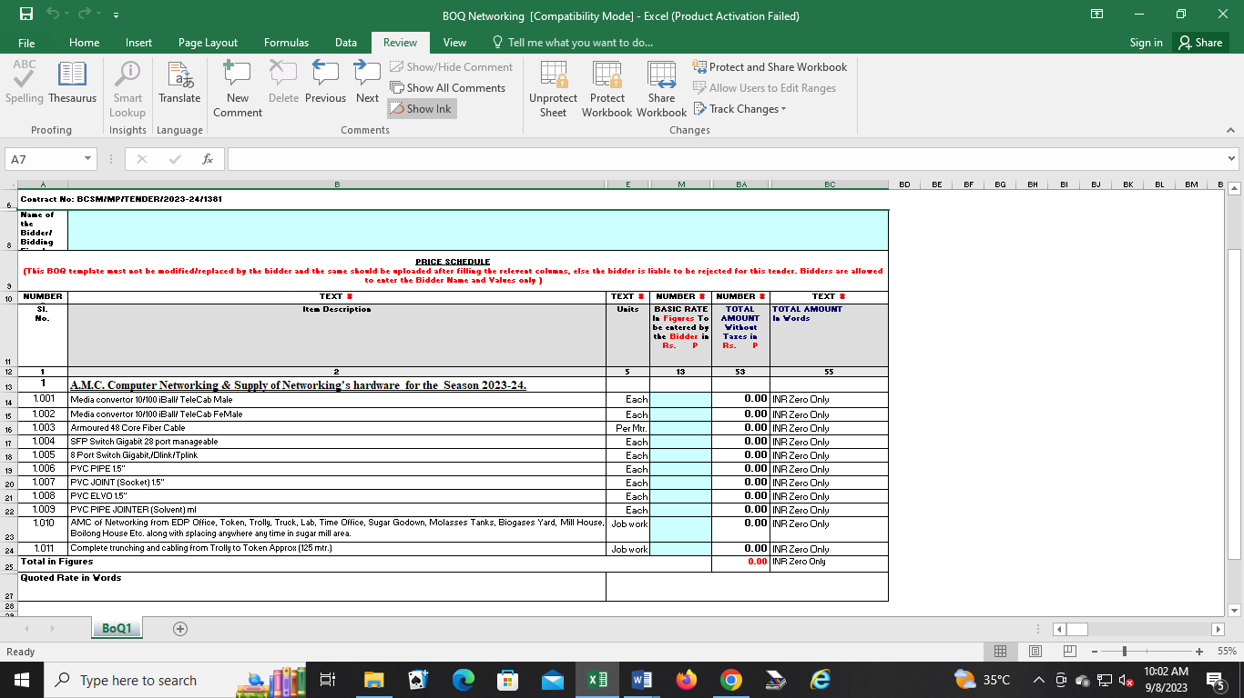

SECTION IV(A): E- bid FORM
Date:
IFB No BCSM/MP/TENDER/2023-24/1381
To:
The General Manager
The Baghpat Co-operative Sugar Mills Ltd., Baghpat
BAGHPAT - 250 609 (U.P.)

Dear Sir,

Having examined the e-Bid Documents, we, the undersigned, offer to A.M.C. Computer Networking & Supply of Networking's hardware for the Season 2023-24. in conformity with the said e-Bid (Section II) of the e-Bid Document and will A.M.C. Computer Networking & Supply of Networking's hardware for the Season 2023-24.
. In addition to this, the particulars of the required e-Bid EMD for Rs. 2000/- ( Rupees Two Thousand Only) in the form of Demand Draft/RTGS pledged in favour of The Baghpat Co-operative Sugar Mills Ltd., Baghpat is being given with this e-Bid form.

We further undertake, if our e-Bid is accepted, to A.M.C. Computer Networking & Supply of Networking's hardware for the Season 2023-24. in accordance within the validity period.

We agree to abide by this e-Bid for the e-Bid validity period specified in Clause 13.1 of the ITB and it shall remain binding upon us and may be accepted at any time before the expiration of that period.

We undertake that, in competing for (and, if the award is made to us, in executing) the above contract, we will strictly observe the laws against fraud and corruption in force in India namely “Prevention of Corruption Act 1998”.

We understand that you are not bound to accept the lowest or any e-Bid you may receive.

Dated this……………………day of ……………….20………….

----------------------------- ----------------------
Signature (in the capacity of)

Duly authorized to sign e-Bid for and on behalf of …………………………….

CHECK LIST

Sl N. | Clause | Instrument/ Documents required | Page No
 | Clause 4 (Invitation for e-Bids) | Cost of e-Bid Document in Physical Form
 | -do- | Scanned Copy of Cost of e-Bid Document
 | Clause 5 (Invitation for e-Bids) | E-Bid EMD in Physical Form
 | ITB Clause | Scanned copy of PAN
 | ITB Clause | Scanned copy of GST Registration
 | ITB Clause | Scanned copy of e-Bid EMD
 | ITB Clause | Copies of work order of A.M.C. Computer Networking & Supply of Networking's hardware for the Season 2023-24. done in other co-op. sugar organizations as a proof of experience if any.
 | Section III (A) | E-Bid form
 | Section IV (A) | E-Bid form
 | T & C | Scanned copy of Terms & Condition

